♀32. Universe (You, The Viewer or All That Is) (Scotch and Soda)—Track 36 

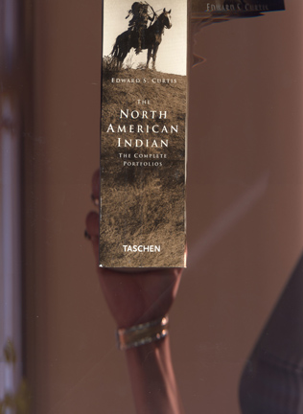
POLITICS—By some measure 2003 was a banner year for elite women scientists. Seventeen (17) women were elected to the prestigious National Academy of Sciences in Washington, D.C., and nine women made it into Britain’s corresponding organization, the Royal Society. But for some inductees, the honor was bittersweet. “Honestly, I thought I should have gotten in a while ago,” says Cynthia Kenyon of the University of California at San Francisco, whose two decades of research since the 1980s on the developmental biology of the nematode worm Caenrhabaditis elegans finally earned her a place in the National Academy. “It sounds like bragging, but I started a whole field in aging—that aging is regulated by hormones, that it is an evolutionarily conserved process. It was a huge discovery.”

All at once she sprang to her feet, “Peter! Peter! Everything is on fire! All the rocks are burning, and the great snow mountain and the sky! O look, look! The high rock up there is red with flame! O the beautiful fiery snow! Stand up, Peter! See, the fire has reach the great bird’s nest! Look at the rocks! Look at the fir trees! Everything, everything is on fire!”
“It is always like that,” said Peter composedly, continuing to peal his stick; “but it is not really fire.”
“What is it then?” cried Heidi, as she ran backwards and forwards to look first at one side and then the other, for she felt she could not have enough of such a beautiful sight. “What is it, Peter, what is it?” she repeated.
“It gets like that of itself,” explained Peter.
“Look, look!” cried Heidi in fresh excitement, “now they have turned all rose color! Look at that one covered with snow, and that with the high, pointed rocks! What do you call them?”
“Mountains have not any names,” he answered.
“O how beautiful! Look at the crimson snow! And there on the rocks there are ever so many roses!”
(To see the roses on the rocks Yourself, just put your fingers over any intense light.)

